|  |  |
| --- | --- |
| Assessment Title | App Development Assignment |

## Competency Details

|  |  |
| --- | --- |
| Unit code/s and title/s | ICTPRG535 Build advanced user interfaces |
| Qualification code/s and title/s | ICT50220 - Diploma of Information Technology |
| Business unit/Work group | BARTS/IT Studies |

## Instructions

|  |  |
| --- | --- |
| Method/s of assessment | Product |
| Overview of assessment | This assessment will require you to implement a database driven shopping list application using Swift and Xcode for iPhone and iPad devices. |
| Task/s to be assessed | This is a practical task and will require you to design and code in the Swift language and XCode IDE.  This assessment will require you to complete the following tasks   * Part I – Identifying the Tools and Planning the UI * Part II – Prototyping the UI * Part III – Implementation * Part IV – Customization/Personalization * Part V – Welcome Screen * Part VI: Testing to Confirm Alignment To UI User Requirements |
| Time allowed | Refer to your schedule for submission dates |
| Location of assessment | Assessment can be completed anywhere with access to the resources required. (see Resources Required section below) |
| Decision making rules | To receive a satisfactory outcome for this assessment you must complete all parts correctly. |
| Assessment conditions | This assessment must be undertaken where the conditions replicate noise levels and interruptions that people typically experience working in the ICT industry.  This is an unsupervised assessment and you may access any required resources.  This is not group work and must be completed as an individual. |
| Resources required | To complete this assignment, you will need to use the following:  MS Word XCode  SQLite Browser  Following document is provided  [ITWorks Swift coding standards](https://learn.tafesa.edu.au/mod/resource/view.php?id=460051) |
| Result notification and reassessment information | You will be provided feedback and the result for your assignment on TAFESA Learn. You will be given the chance to resubmit with required corrections only once.  Refer to the TAFE SA assessment policy for more information <https://www.tafesa.edu.au/apply-enrol/before-starting/student-policies/assessment> |

### App Development Assignment

### Developing a Shopping List iOS Application

### Background

A customer has approached ITWorks to implement a database driven shopping list application for iOS users. ITWorks have requested you to build a prototype to demonstrate to the client. Your application will help users to manage their shopping with some added functionality. Please note that your lecturer will act as the client.

The application will allow users to store and manage their shopping list. The user will be able to perform following functionalities.

**Functionalities**

* **Add Items to the shopping List** – User will be able to add new shopping items to the list. Each item should have item name, price, type, and quantity.
* **Display Items** – User will be able to view the shopping list.
* **Remove Items** – User will be able to remove items from the list.
* **Settings**
  + User will be able to customize the applications by changing the background colour.
  + Application will be able to display nearby shops based on the user location

**Part I –** **Identifying the Tools and Planning the UI**

Based on the client requirements, identify a suitable technology to implement the application. Produce a conceptual design of the user interface such as Tab View, Navigation View and submit for client feedback . Your user interface should fit different models of iPhone and iPad.

1. You need to provide a document containing the following items for client feedback. Save your document as UI Design Plan_V1.docx and submit to LEARN when you complete the Part I – a.
2. Target platforms to implement the application.

* IOS

1. A suitable development environment (IDE)

* Xcode

1. Two tools or technologies to be used

* Swift, mapKit

1. Screenshots of the conceptual design of the UI (hand-drawn designs are acceptable) which must include the global navigation scheme and the user interaction schemes with at least 3 views.

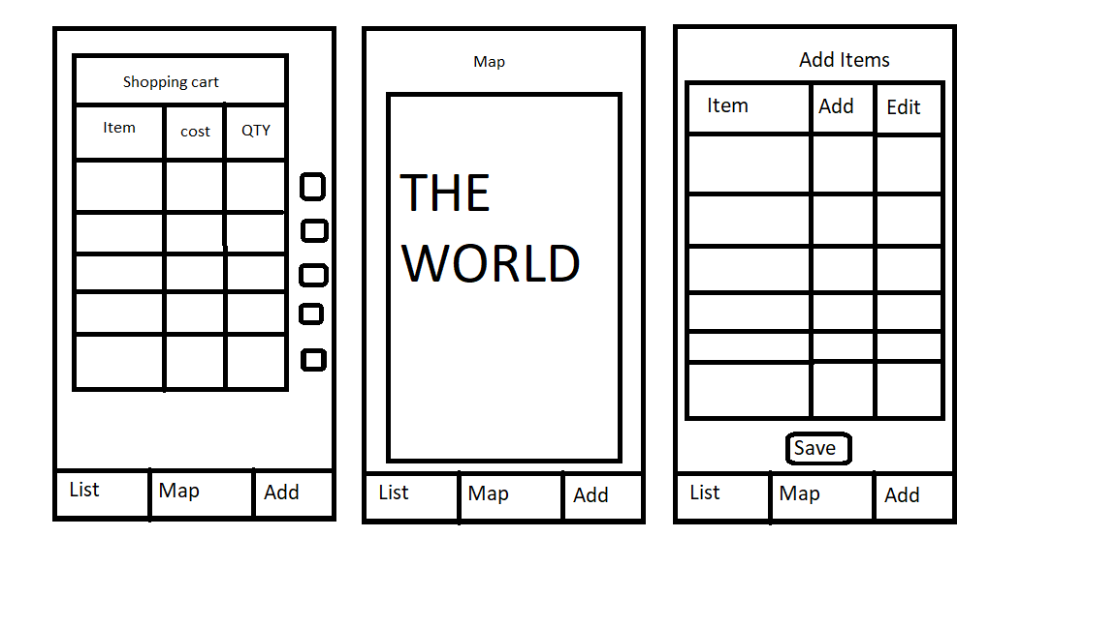

1. Identify a personalization option for the UI based on the client

The only personalisation option is the map.

Upload your document UI Design Plan_V1.docx to learn for client feedback.

1. Based on the client feedback update the document (UI Design Plan_V2.docx) and submit to LEARN.